Internship Fieldwork Application User Guide

By Daniel Dalton and Seraphim Dmitrieff

Table of Contents

**1. Some Notes for Future Developers** **2**

**2. For the Career Resource Center** **5**

2.1 - Creating a New User as the Career Resource Center 6

2.2 - Looking up a User as the Career Resource Center 8

2.3 - Deletion of a User as the Career Resource Center 8

2.4 - Creation of a Department 9

2.5 - “Edit Permissions” of a Department 10

2.6 - E-mail Preferences for a Department 10

2.7 - Future Admin Tool Plans 11

**3. New Users** **12**

**4. Secretaries** **13**

4.1 - Creation of a New Student Account 13

4.2 - Creation of a New Application 14

**5. Students** **16**

**6. Instructors** **17**

**7. Department Chairs and Deans** **19**

**8. Records and Registration** **20**

# 1. Some Notes for Future Developers

At the time of writing, this system is not yet complete. Our objectives that have yet to be completed is in a ToDo file in our project directory. However, this User Guide will not cover our code and functions used in our PHP. You can read more about that in our Programmer’s Manual. Our Utility Functions (backend/util.php) are also documented in [PHPdoc notation (https://www.phpdoc.org/)](https://www.phpdoc.org/).

This User Guide is meant to be a manual for those interested in using the system. These people include: Students looking to file Internship as Field Work for Course Credit, their Employers, their supervising Instructors, their Department Chairs, their Department Deans, the Records and Registration Office, and the Career Resource Center’s Office.

We highly recommend keeping in close touch with the Records and Registration Office and the Career Resource Center in the development of this system, since project requirements can be subject to change at any moment. We also highly recommend showing demos of this project to different departments in the school, since they sometimes handle student field work very differently.

As a short description of our system, see Figure 1.1.

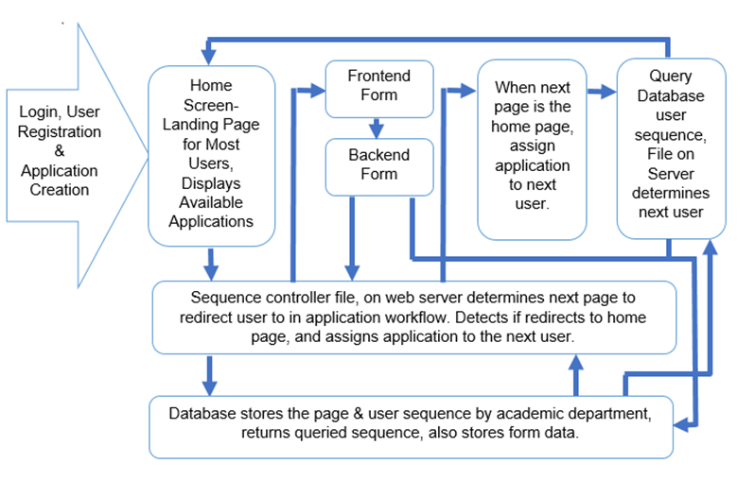

Figure 1.1: Sequencing of our Application is determined by a Sequence Controller.

We’ve also carefully followed the New Paltz Identity Standards and Style Guide while developing this application, and recommend that you continue to follow it. The style guide can be found at <https://www.newpaltz.edu/media/identity/identitystandards.pdf>.

# For the Career Resource Center

The Career Resource Center is recognized by the system as an Administrative User (or admin).

After logging in, the Career Resource Center may:

* Search for a user by their e-mail address.
* Create a new user (of any type).
* Look up a Department.
* Create a new Department.

Some admin tools we plan on implementing later are:

* Modifying e-mail text.
* Modifying application sequence (by department).
* Editing any user’s profile or login information (or sending them an e-mail prompting them to reset their password).

Figure 2.0.1 shows a screenshot of their home page:

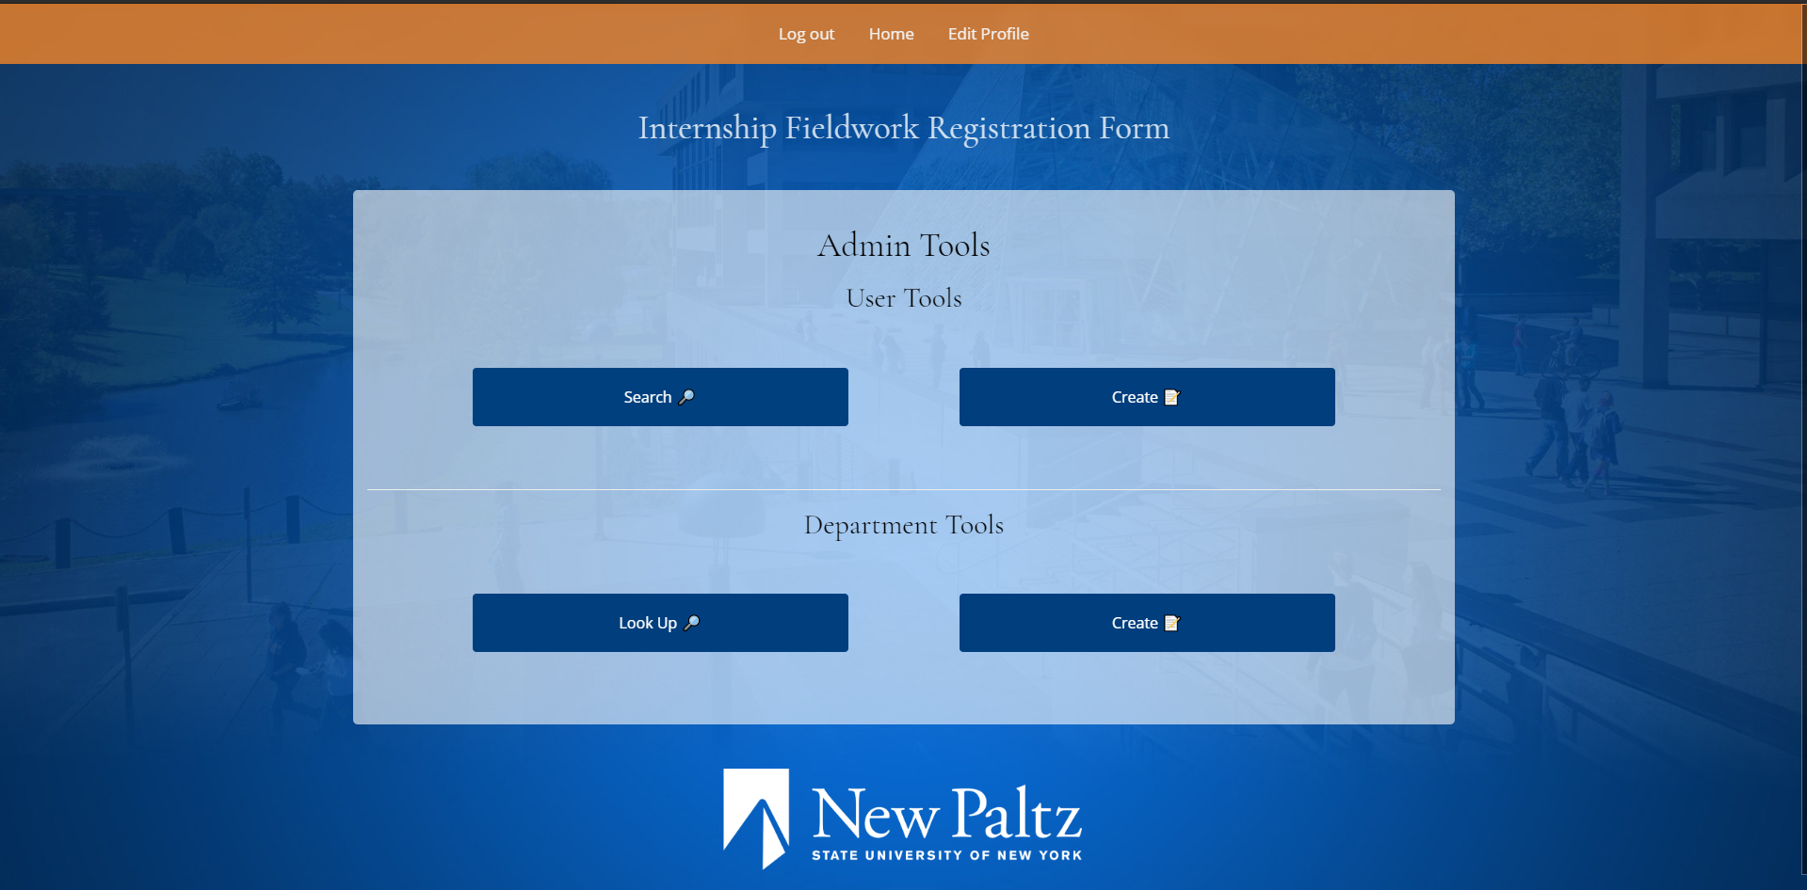

Figure 2.0.1: A screenshot of the tools available at the Career Resource Center’s disposal.

## Creating a New User as the Career Resource Center

Creating a new user is fairly straightforward as the Career Resource Center.

Once you’re logged in, click the “Create” button under User Tools (shown with a Notepad emoji 📝). Once you’ve done that, you’ll be prompted to enter some information about the user, including their e-mail address, their Banner ID, their initial password and a confirmation of that password, and that user’s User Type. This user type can be any recognized type of user in the system including: Student, Secretary, Employer, Instructor, Department Chair, Dean, Administrator, or Records and Registration. Figure 2.1.1 shows a screenshot of the dialog shown.

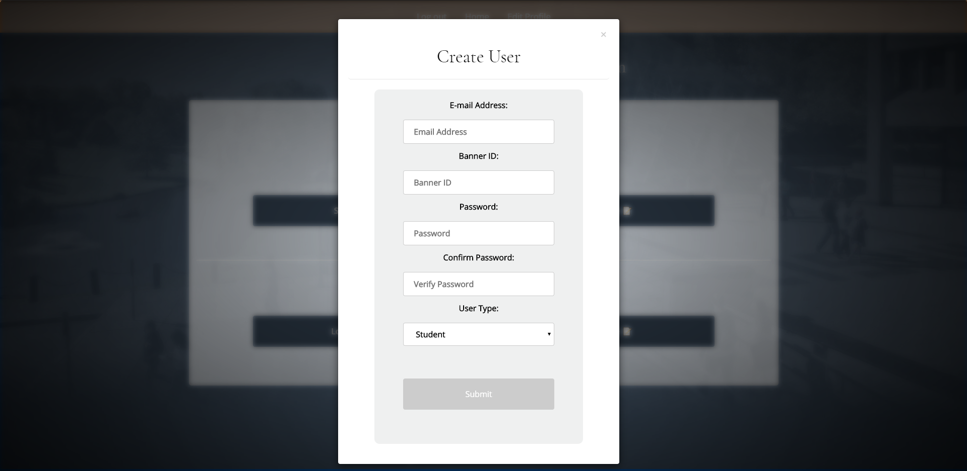

Figure 2.1.1: A screenshot showing the modal dialog to create a new user.

## Looking up a User as the Career Resource Center

If you know a user’s email, you may look it up, and then enter it into the dialog box presented when you click on “Look Up 🔎”. When you do, you’ll be presented with the user’s information as another modal dialog, as shown in Figure 2.2.1.

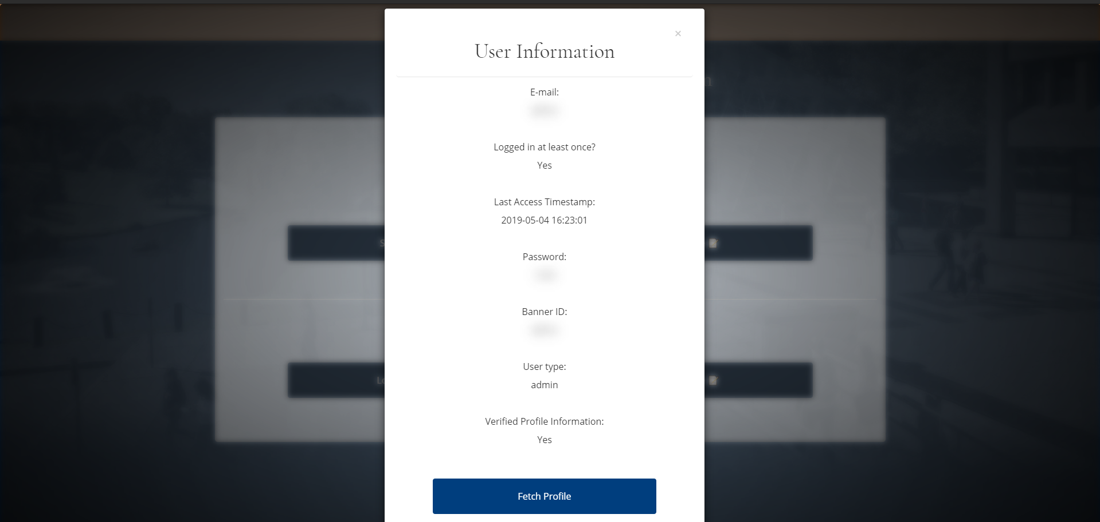

Figure 2.2.1: User Information presented as a modal dialog box. Actual information is shown blurred in the screenshot.

Upon clicking “Fetch Profile,” you’ll find more information on that person, including their name and other details, depending on their user type.

## Deletion of a User as the Career Resource Center

To delete a user, look up the user first. When you see the dialog shown in Figure 2.2.1, scroll down to the bottom of the modal dialog. You will see a button that looks similar to the button shown in Figure 2.3.1.

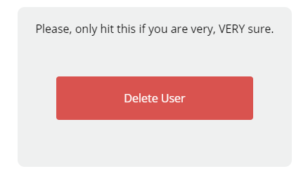

Figure 2.3.1: The “Delete User” button.

As the text above the button shows, please only hit the button if you are very, VERY sure, as you won’t be able to recover any of that user’s information afterwards, including their user profile and any applications they might have filed.

## Creation of a Department

To create a department, log in, and, under “Department Tools,” click “Create 📝". This will bring up a modal dialog box asking you to specify the name of the department, a department code, and there should be drop-down boxes allowing you to select a chair and dean of the department by their e-mail addresses.

**Note: The dean and chair of the newly created department should already have profiles before you start this process.** You will need to start by creating their profiles before you can complete any tasks. To create profiles for them, see “2.1 - Creating a User as the Career Resource Center.” **Once the department is created, the next time the new chair and dean log in, they’ll be prompted to update their profile information.** When they update their information, they should include that newly created department.

At creation time, you may also specify permissions for staff to edit certain portions of the application’s information (See Section 2.5). You may also specify preferences for the department as for which events certain staff will receive e-mails (See Section 2.6). Note that information entered here can be edited later on after looking up the department.

## “Edit Permissions” of a Department

Edit Permissions specify which items certain staff members may edit of an application. These may be modified after the department has been created, or specified with the department’s creation.

A member of the Career Resource Center may edit whether or not these statements hold true for certain departments:

* Instructor may modify course information.
* Instructor may modify project information.
* Instructor may modify employer information.
* Employer may modify project information.
* Employer may edit instructor submitted learning objectives.
* Department chair may edit course information.
* Department chair may edit project information.
* Department chair may edit employer information.
* Department chair may edit learning objectives.
* Dean can modify course information.
* Dean can modify project information.
* Dean can modify learning objectives.

## E-mail Preferences for a Department

Much like editing permissions, e-mail preferences are set at department creation time and can be modified later.

E-mail preferences can be set by type of user (student, instructor, dean, chair, employer) and can be set to notify if they get rejection e-mails, general updates, and reminder e-mails.

Students get reminder e-mails after 5 days of inactivity, and each other type of user gets reminders after 7 days of inactivity. Reminder e-mails will be sent every day until they log back into the system.

## Future Admin Tool Plans

At the time of writing this user guide, we’ve yet to implement a front end admin control for sequence control modification. This should be set at department creation time and can be modifiable later.

We also plan on including an administrative tool to edit the contents of e-mails to allow the Career Resource Center full control of wording.

The Career Resource Center should also be able to see all applications in the system, and delete/modify applications at will for any department.

The Career Resource Center should also be able to act as any user.

# New Users

A new user of any type will be prompted to do two things upon logging in:

1. Submit a new password into the system.
2. Update their User Profile with some personal information. For students, this will include their address, and for faculty members, this will include their office hours and departments. For employers, this will include the name of their business and some information on that.

Once they’ve logged in, any user may see applications assigned to them (besides Department Secretaries, the Career Resource Center, and Records and Registration). Students will see applications *they’ve created* instead, along with a progress bar and where it’s now assigned.

Your information may be edited at any time.

If you forget your password, click the “Forgot Password?” link on the login page. You’ll be prompted for a Banner ID number, and you’ll receive a newly randomly generated password via e-mail that you reset once you log in.

**Employers:** Since you won’t have real Banner ID’s, you will need to use an E-id number.. You will receive an email with your E-id number when your account is generated (Example: E10). This ID is only used in the case of resetting your password, so please keep it in a safe place.

# Secretaries

Secretaries can create new student accounts and create new application workflows.

When you log in, you’ll be prompted to edit a student’s Banner ID number. Enter their Banner ID number *regardless of whether or not that student exists in the system.* If you’re prompted to enter their e-mail, continue to Section 4.1. Otherwise, skip to Section 4.2.

## Creation of a New Student Account

If you’ve entered in the student’s Banner ID number and you get a red message with “No User Found” and you are prompted to enter their e-mail, that means they do not yet have an account.

Enter the student’s e-mail in the box presented to you. This will make a new student user account with their Banner ID and e-mail address tied to with it, with a randomly generated password. *This password will be sent to their e-mail, and once you enter their e-mail, you’ll get a message prompting you to have them check their e-mail.* This is for that password.

That e-mail should look something like Figure 4.1.1. Note that it looks like it’s coming from the Career Resource Center - this is for security reasons.

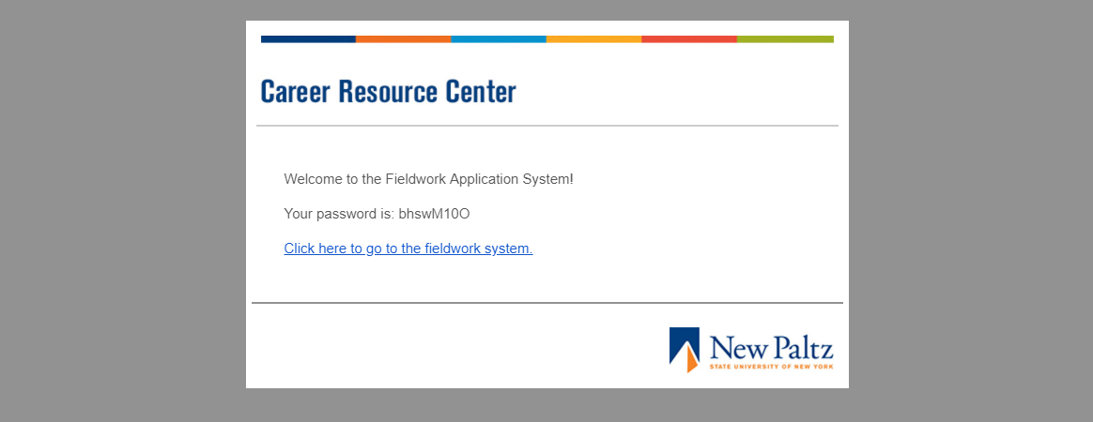

Figure 4.1.1: Students will get an e-mail with their password.

Once they get this e-mail, have that student log in and complete their profile. After that, enter in their Banner ID number again, and continue on assigning them an application with the instructions from Section 4.2.

## Creation of a New Application

If you get a green message saying “Found User!” and a page asking you to select a department, the student exists and you can assign them a new application.

First, select the department the student is going through for this piece of Fieldwork. For example, if the student is working through the Computer Science department, select “Computer Science.” If the department doesn’t yet exist, contact the Career Resource Center.

Next, select their professor within this department.

If there aren’t any professors in this selected department, the page may say “We Have a Problem.” This is a worrisome message that translates to, there’s a department without any professors in it. If this happens, contact the Career Resource Center, or a professor in the department with a profile.

Figure 4.2.1 shows an example of selecting a department and a professor within that department.

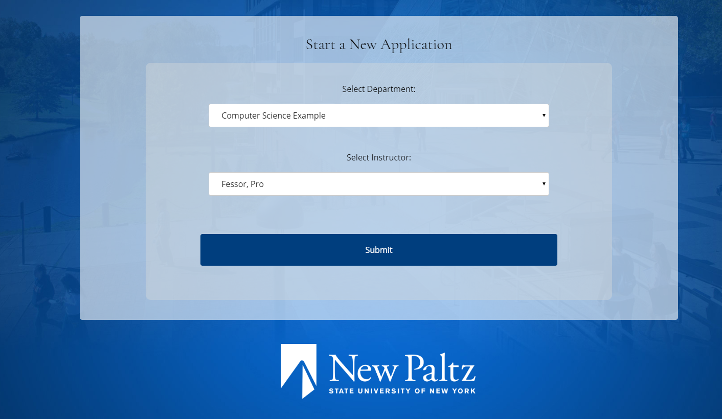

Figure 4.2.1: Selection of a department and a professor to assign the application to.

Once that is done, click the Submit button, and the application will be created. You’ll then be redirected back to the screen where the student enters in their Student ID.

# Students

To start the process of adding internship field work as course credit, please talk to your Department Secretary. Once you’re able to log in and you have a piece of field work on your profile assigned to you, log in and submit the information presented to you. This information can include, but is not limited to:

* Course Information
* Employer Information
* Project Information

Once you fill out what you need to fill out, you’ll have a chance to review your information that was submitted.

From there, you’ll be able to view progress on your application as a progress bar with a small description under it, and, if your department allows it, you’ll get updates when your application gets pushed onto the next person in your department.

Depending on your department and how it’s set up, you may also get e-mails if your application gets rejected at any point, and you may get reminder e-mails if it’s been 5 days since you had an application assigned to you for any reason.

If it gets rejected, the person that rejected it can leave a comment viewable next to the progress bar. Take the advice with the comment, and try again!

# Instructors

Once you get an application assigned to you, you must review it before it can proceed to the next user. If you do nothing for 7 days, depending on how your department has it set up, you’ll get a reminder e-mail reminding you to get on the system every day until you fill it out.

Depending on how your department has it set up, you’ll get up to five pages.

* Review of Application information.

When you review application information, you’ll get a chance to review Course Information and Project information. If your department allows it, you may edit this information if it’s a quick edit (say, a typo).

Otherwise, you may accept or reject the application at this point. If you reject it, you must provide an explanation.

* Review of Employer Information.

When you review employer information, you can either accept it, make a quick edit if your department allows that, or reject it (again, you’d have to provide an explanation).

* Enter Learning Objectives.

You’ll have to enter the learning objectives the student had to accomplish while working with the department. As you type these, you’ll have an opportunity to select learning objectives from the database if they exist in there already.

* Upload a Syllabus.

You can upload a syllabus that other staff may refer to when reviewing the student’s application. *In the future, we’d like instructors to be able to pick through syllabi that they or anyone else in the department has submitted before, and they’re named in the system after the department code.*

* Final Review.

You’ll get a chance to review your information that was submitted before sending it to the next person in your department. You may make edits on this page.

# Department Chairs and Deans

Department Chairs and Deans may get applications assigned to them, depending on their department. If they do, they will get a page reviewing the information that was submitted to them.

Department Chairs and Deans may:

* Edit the information, if the department gives them the permission to.
* Accept the information and submit the information to the next staff member.
* Reject the information, provide a reason, and send it back to the previous staff member.

If your account is inactive for seven days, depending on your e-mail preferences, you’ll get an e-mail reminding you to get on your profile, depending on how your department is set up.

You’ll additionally get e-mails for general updates and rejections, depending on your department’s e-mail preferences. To change these, speak with the Career Resource Center.

# Records and Registration

The page for the Records and Registration office has yet to be implemented. However, when the page does get implemented, they may view completed applications at any point in time.